
RAMAIAH
Institute of Technology
USN | 1 | M | S

(Autonomous Institute, Affiliated to VTU)
(Approved by AICTE, New Delhi & Govt. of Karnataka) Accredited by NBA & NAAC with ‘A’ Grade

SUPPLEMENTARY SEMESTER EXAMINATIONS – AUGUST 2019

Course & Branch | : | B.E. : Computer Science and Engg / Information Science and Engg | Semester | : | IV
Subject | : | Engineering Mathematics - IV | Max. Marks | : | 100
Subject Code | : | CS / IS41 | Duration | : | 3 Hrs

Instructions to the Candidates:
- Answer one full question from each unit.

 |  | UNIT- I
1. | a) | Write the formulae to find 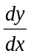and 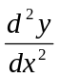by using Newton-Gregory forward interpolation formula when p=0 | CO1 | (02)
 | b) | The velocity of a particle at distance from a point on its path is given by the table. Estimate the time taken to travel 60 ft by using Simpson’s 1/3 rule. | CO1 | (04)
  (ft) | 0 | 10 | 20 | 30 | 40 | 50 | 60
  (ft/sec) | 47 | 58 | 64 | 65 | 61 | 52 | 38
 | c) | Find an interpolating polynomial representing the following data using Newton’s divided difference method and hence find f(1.4) | CO1 | (07)
   | 0 | 1 | 2 | 3
  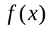 | 2 | 3 | 12 | 147
 | d) | From the following data estimate the number of persons having income between 2000 and 2500. | CO1 | (07)
  Income | 500-1000 | 1000-2000 | 2000-3000 | 3000-4000
  No. of persons | 4250 | 3600 | 1500 | 650
2. | a) | Write the Simpson’s 3/8th rule for numerical integration. | CO1 | (02)
 | b) | From the following data, find for 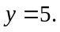 using the inverse Lagrange’s interpolation formula. | CO1 | (04)
   | 2 | 10 | 17
   | 1 | 3 | 4
 | c) | From the set of tabulated values find the value of at which there is an extreme and hence find the maximum and minimum values of 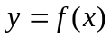. | CO1 | (07)
   | 0 | 1 | 2 | 3 | 4
   | 6 | -5 | -16 | -12 | -10
 | d) | The table gives the distances in nautical miles of the visible horizon for the given heights in feet above the earth’s surface.  Find the values of , when i) 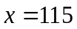ft and ii) 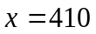ft. | CO2 | (07)
  Height 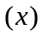 | 100 | 150 | 200 | 250 | 300 | 350 | 400
  Distance 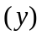 | 10.63 | 13.03 | 15.04 | 16.81 | 18.42 | 19.90 | 21.27
 |  | UNIT- II
3. | a) | A random variable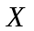has the density function 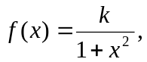  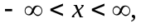determine . | CO2 | (02)
 | b) | The probability that a bomb dropped from a plane will strike the target is 1/5 If six bombs are dropped, find the probability that (i) exactly two will strike the target (ii) atleast two will strike the target. | CO2 | (04)
 | c) | The sales per day in a shop is exponentially distributed with average sale amounting to Rs.100 and net profit is 8%. Find the probability that the net profit exceeds Rs.30 on two consecutive days. | CO2 | (07)
 | d) | In an examination 7% of students score less than 35 marks and 89% of students score less than 60 marks. Find the mean and the standard deviation if the marks are normally distributed. | CO2 | (07)
4. | a) | The mean and variance of a binomial variatewith parameters 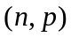 are 16 and 8. Find the distribution of . | CO2 | (02)
 | b) | If a random variable k is uniformly distributed over (0,5). What is the probability that, the roots of the equation 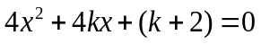 are real. | CO2 | (04)
 | c) | The probability density function of a variate X is  Find: (i) 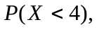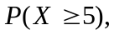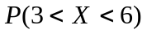 (ii) Mean and variance (iii) What will be the minimum value of k so that 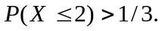 | CO2 | (07)
   | 0 | 1 | 2 | 3 | 4 | 5 | 6
  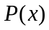 | k | 3k | 5k | 7k | 9k | 11k | 13k
 | d) | The number of accidents per day on a certain highway is a gamma variate with an average 6 and variance 18. Find the probability that there will be (i) more than 8 accidents (ii) between 5 and 8 accidents (iii) at most 5 accidents. | CO2 | (07)
 |  | UNIT- III
5. | a) | Define stochastic processes. | CO3 | (02)
 | b) | A fair coin is tossed three times. Let Xdenote0 or 1 according as the head or tail occurs on the first toss. Let Y denote the number of heads which occur. Find the joint distribution table of X and Y. | CO3 | (04)
 | c) | If X and Y are continuous random variables having the joint density function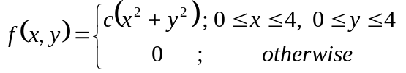. Find  (i) the value of c (ii) 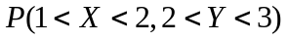 and (iii)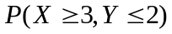. | CO3 | (07)
 | d) | Show that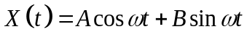, where A and B are uncorrelated random variables each with mean 0 and variance 1 and ω is a positive constant, is a WSS. | CO3 | (07)
6. | a) | Find the marginal distribution of X and Y given that | CO3 | (02)
  x\y | -4 | 2 | 7
  1 | 1/8 | 1/4 | 1/8
  5 | 1/4 | 1/8 | 1/8
 | b) | Write the expressions for Autocorrelation, Auto covariance and correlation coefficient of the random process. | CO3 | (04)
 | c) | A bag contains 3 white, 2 red, 2 green bulbs are contained and randomly two bulbs are selected randomly without replacement. If X and Y are discrete random variables denoting number of white and red bulbs respectively, Determine (i) joint distribution of X and Y (ii) Marginal distribution of X and Y & (iii) 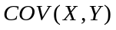. | CO3 | (07)
 | d) | A stochastic process with its ensemble functions are assumed to have equal probabilities are given by: 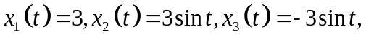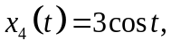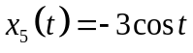,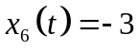. Show that the process is WSS but not SSS. | CO3 | (07)
 |  | UNIT- IV
7. | a) | Define Absorbing state. | CO4 | (02)
 | b) | Trains arrive at the yard every 15 minutes and the service time is 33 minutes. If the line capacity of the yard is limited to 5 trains, find the probability that the yard is empty and the average number of trains in the system. | CO4 | (04)
 | c) | There are 2 white marbles in bag A and 3 red marbles in bag B. At each step of the process a marble is selected at random from each bag and the two marbles selected are interchanged then find (i) transition probability matrix (ii) what is the probability that there are 2 red marbles in A after 3 steps (iii) In the long run what is the probability that there are 2 red marbles in A? | CO4 | (07)
 | d) | Patients arrive at a clinic according to Poisson distribution at a rate of 30 patients per hour. The waiting room does not accommodate more than 14 patients. Examination time per patient is exponential with mean rate of 20 per hour. (i) Find the effective arrival rate at the clinic (ii) What is the probability that an arriving patient does not have to wait? (iii) What is the expected waiting time until a patient is discharged from the clinic? | CO4 | (07)
8. | a) | Define M/M/1 queuing system. | CO4 | (02)
 | b) | Find the fixed probability vector of 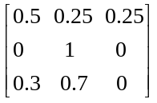 | CO4 | (04)
 | c) | In a heavy machine shop, the overhead crane is 75% utilized. Time study observations gave the average service time as 10.5 mins, with a standard deviation 8.8 mins. What is the average calling rate for the services of the crane and what is the average delay in getting service? If the average service time is cut to 8 mins, with standard deviation of 6 mins how much reduction will occur, an average in the day delay of getting served. | CO4 | (07)
 | d) | Two boys b₁ and b₂ and two girls g₁ and g₂ are throwing a ball from one to the other. Each boy throws the ball to the other with probability ½ and to each girl with probability ¼. On the other hand, each girl throws the ball to each boy with probability ½ and never to the girl. In the long run, how often does each receive the ball? | CO4 | (07)
 |  | UNIT- V
9. | a) | Write a short note on Testing of hypothesis. | CO5 | (02)
 | b) | A die was thrown 9000 times and a throw of 5 or 6 was obtained 3240 times. On the assumption of random throwing, do the data indicate an unbiased die? | CO5 | (04)
 | c) | A group of 10 rats fed on a diet A and another group of 8 rats fed on a different diet B recorded the following increase in weights in gms.  Test whether the diet A is superior to diet B. | CO5 | (07)
  Diet A | 5 | 6 | 8 | 1 | 12 | 4 | 3 | 9 | 6 | 10
  Diet B | 2 | 3 | 6 | 8 | 1 | 10 | 2 | 8 | - | -
 | d) | Five Coins are tossed 320 times. The number of heads observed is given below. Examine whether the coin is unbiased. | CO5 | (07)
  No. of heads | 0 | 1 | 2 | 3 | 4 | 5
  Frequency | 15 | 45 | 85 | 95 | 60 | 20
10. | a) | Define Type I and Type II errors. | CO5 | (02)
 | b) | A sample of 12 measurements of the diameter of a metal ball gave the mean=7.38mm with Standard deviation. S =1.24mm, Find 95% confidence limits for the actual diameter. | CO5 | (04)
 | c) | A population consists of the four numbers 3, 7, 11, 15. Consider all possible samples of size 2 which can be drawn (i) with replacement and (ii) without replacement from this population. In both the cases find (iii) the population mean (iv) the population standard deviation. | CO5 | (07)
 | d) | Two independent samples of sizes 7 and 6 have the following values:  Examine Whether the samples have been drawn from normal population having the same variance? | CO5 | (07)
  Sample A | 28 | 30 | 32 | 33 | 33 | 29 | 34
  Sample B | 29 | 30 | 30 | 24 | 27 | 29 | -

****************

